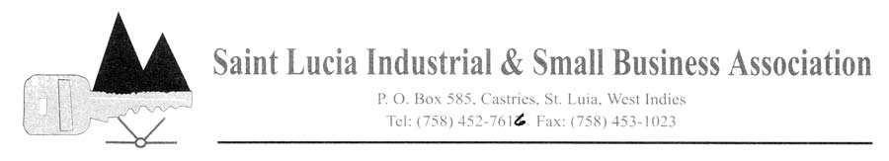

Membership Application Form
(Article 4.2 of the Bye-Laws)

COMPANY/INDIVIDUAL: …………………………………………………………………………………...……………… MAILING/ADDRESS: ……………………………………………………………………………………….……………… STREET ADDRESS: ………………………………………………………………………………………………………… TELEPHONE: …………………………………….CELL: ……………………………FAX: ……...………………………
E-MAIL ADDRESS: ………………………………………………………………………………………………………… WEBSITE: …………………………………………………………………………………………………………………….. TYPE OF BUSINESS: ………………………………………………………………………………………………………. NO. OF EMPLOYEES: ……………………………………………………………………………………………………… COMPANY REPRESENTATIVE: ………………………………………………………………………………………….. ALTERNATE: ……………………………………………………………………………………………………………….. SIGNED: ………………………………………………………………DATE: ……………………………………………...
POSITION: …………………………………………………………………………………………………………………….

ORDINARY MEMBERSHIP: | ASSOCIATE MEMBERSHIP | GROUP MEMBERSHIP
ANNUAL SUBSCRIPTION $ 500.0  0 | EC$ 1,500.00 | EC$ 1,000.00

NONE REFUNDABLE PROCESSING FEE: $25

OFFICIAL USE:

Date received: ………………………………….. Date Approved: ………………………………………………… Amount paid: $……………………………………. Company Classification: …………………………………… Signed by: ………………………………………………………………
Position: ………………………………………….

LET YOUR VOICE BE HEARD!!!!

